**Inter Process Communication (IPC)**

A process can be of two types:

* Independent process.
* Co-operating process.

An independent process is not affected by the execution of other processes while a co-operating process can be affected by other executing processes. Though one can think that those processes, which are running independently, will execute very efficiently, in reality, there are many situations when co-operative nature can be utilized for increasing computational speed, convenience, and modularity. Inter-process communication (IPC) is a mechanism that allows processes to communicate with each other and synchronize their actions. The communication between these processes can be seen as a method of co-operation between them. Processes can communicate with each other through both:

1. Shared Memory
2. Message passing

An operating system can implement both methods of communication. First, we will discuss the shared memory methods of communication and then message passing. Communication between processes using shared memory requires processes to share some variable, and it completely depends on how the programmer will implement it. One way of communication using shared memory can be imagined like this: Suppose process1 and process2 are executing simultaneously, and they share some resources or use some information from another process. Process1 generates information about certain computations or resources being used and keeps it as a record in shared memory. When process2 needs to use the shared information, it will check in the record stored in shared memory and take note of the information generated by process1 and act accordingly. Processes can use shared memory for extracting information as a record from another process as well as for delivering any specific information to other processes.

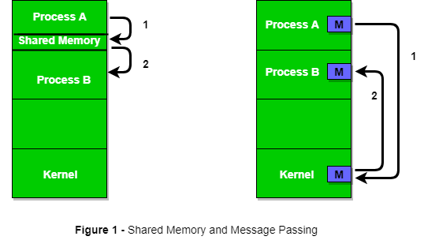

**MEMORY MANAGEMENT**

Memory management is the functionality of an operating system which handles or manages primary memory and moves processes back and forth between main memory and disk during execution. Memory management keeps track of each and every memory location, regardless of either it is allocated to some process or it is free. It checks how much memory is to be allocated to processes. It decides which process will get memory at what time. It tracks whenever some memory gets freed or unallocated and correspondingly it updates the status.

This tutorial will teach you basic concepts related to Memory Management.

Process Address Space

The process address space is the set of logical addresses that a process references in its code. For example, when 32-bit addressing is in use, addresses can range from 0 to 0x7fffffff; that is, 2^31 possible numbers, for a total theoretical size of 2 gigabytes.

The operating system takes care of mapping the logical addresses to physical addresses at the time of memory allocation to the program. There are three types of addresses used in a program before and after memory is allocated –

|  |  |
| --- | --- |
| **S.N.** | **Memory Addresses & Description** |
| 1 | **Symbolic addresses**  The addresses used in a source code. The variable names, constants, and instruction labels are the basic elements of the symbolic address space. |
| 2 | **Relative addresses**  At the time of compilation, a compiler converts symbolic addresses into relative addresses. |
| 3 | **Physical addresses**  The loader generates these addresses at the time when a program is loaded into main memory. |

Virtual and physical addresses are the same in compile-time and load-time address-binding schemes. Virtual and physical addresses differ in execution-time address-binding scheme.

The set of all logical addresses generated by a program is referred to as a **logical address space**. The set of all physical addresses corresponding to these logical addresses is referred to as a **physical address space.**

# **Memory Organization in Computer Architecture**

A memory unit is the collection of storage units or devices together. The memory unit stores the binary information in the form of bits. Generally, memory/storage is classified into 2 categories:

* **Volatile Memory**: This loses its data, when power is switched off.
* **Non-Volatile Memory**: This is a permanent storage and does not lose any data when power is switched off.

## Memory Hierarchy

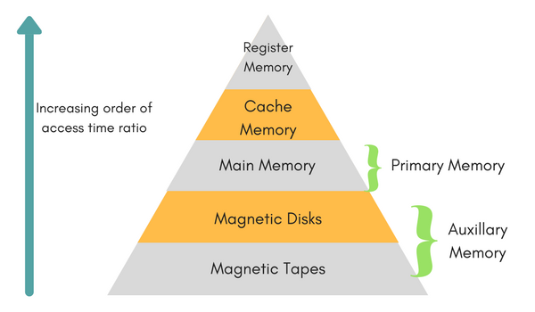

The total memory capacity of a computer can be visualized by hierarchy of components. The memory hierarchy system consists of all storage devices contained in a computer system from the slow Auxiliary Memory to fast Main Memory and to smaller Cache memory.

**Auxillary memory** access time is generally **1000 times** that of the main memory, hence it is at the bottom of the hierarchy.

The **main memory** occupies the central position because it is equipped to communicate directly with the CPU and with auxiliary memory devices through Input/output processor (I/O).

When the program not residing in main memory is needed by the CPU, they are brought in from auxiliary memory. Programs not currently needed in main memory are transferred into auxiliary memory to provide space in main memory for other programs that are currently in use.

The **cache memory** is used to store program data which is currently being executed in the CPU. Approximate access time ratio between cache memory and main memory is about **1 to 7~10**

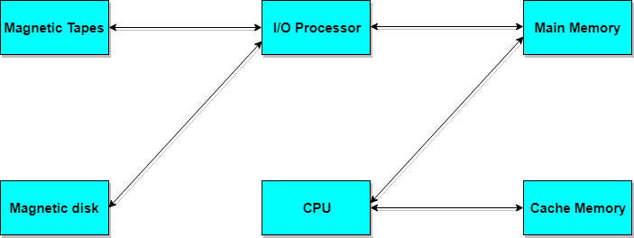

## Memory Access Methods

Each memory type, is a collection of numerous memory locations. To access data from any memory, first it must be located and then the data is read from the memory location. Following are the methods to access information from memory locations:

1. **Random Access**: Main memories are random access memories, in which each memory location has a unique address. Using this unique address any memory location can be reached in the same amount of time in any order.
2. **Sequential Access**: This methods allows memory access in a sequence or in order.
3. **Direct Access**: In this mode, information is stored in tracks, with each track having a separate read/write head.

## Main Memory

The memory unit that communicates directly within the CPU, Auxillary memory and Cache memory, is called main memory. It is the central storage unit of the computer system. It is a large and fast memory used to store data during computer operations. Main memory is made up of **RAM** and **ROM**, with RAM integrated circuit chips holing the major share.

* RAM: Random Access Memory
  + **DRAM**: Dynamic RAM, is made of capacitors and transistors, and must be refreshed every 10~100 ms. It is slower and cheaper than SRAM.
  + **SRAM**: Static RAM, has a six transistor circuit in each cell and retains data, until powered off.
  + **NVRAM**: Non-Volatile RAM, retains its data, even when turned off. Example: Flash memory.
* ROM: Read Only Memory, is non-volatile and is more like a permanent storage for information. It also stores the **bootstrap loader** program, to load and start the operating system when computer is turned on. **PROM**(Programmable ROM), **EPROM**(Erasable PROM) and **EEPROM**(Electrically Erasable PROM) are some commonly used ROMs.

## Auxiliary Memory

Devices that provide backup storage are called auxiliary memory. **For example:** Magnetic disks and tapes are commonly used auxiliary devices. Other devices used as auxiliary memory are magnetic drums, magnetic bubble memory and optical disks.

It is not directly accessible to the CPU, and is accessed using the Input/Output channels.

### **Cache Memory**

The data or contents of the main memory that are used again and again by CPU, are stored in the cache memory so that we can easily access that data in shorter time.

Whenever the CPU needs to access memory, it first checks the cache memory. If the data is not found in cache memory then the CPU moves onto the main memory. It also transfers block of recent data into the cache and keeps on deleting the old data in cache to accomodate the new one.

### **Hit Ratio**

The performance of cache memory is measured in terms of a quantity called **hit ratio**. When the CPU refers to memory and finds the word in cache it is said to produce a **hit**. If the word is not found in cache, it is in main memory then it counts as a **miss**.

The ratio of the number of hits to the total CPU references to memory is called hit ratio.

Hit Ratio = Hit/(Hit + Miss)

## Associative Memory

It is also known as **content addressable memory (CAM)**. It is a memory chip in which each bit position can be compared. In this the content is compared in each bit cell which allows very fast table lookup. Since the entire chip can be compared, contents are randomly stored without considering addressing scheme. These chips have less storage capacity than regular memory chips.

**Storage Allocation Virtual Memory Concept**

Virtual Memory is a storage allocation scheme in which secondary memory can be addressed as though it were part of main memory. The addresses a program may use to reference memory are distinguished from the addresses the memory system uses to identify physical storage sites, and program generated addresses are translated automatically to the corresponding machine addresses.  
The size of virtual storage is limited by the addressing scheme of the computer system and amount of secondary memory is available not by the actual number of the main storage locations.

It is a technique that is implemented using both hardware and software. It maps memory addresses used by a program, called virtual addresses, into physical addresses in computer memory.

1. All memory references within a process are logical addresses that are dynamically translated into physical addresses at run time. This means that a process can be swapped in and out of main memory such that it occupies different places in main memory at different times during the course of execution.
2. A process may be broken into number of pieces and these pieces need not be continuously located in the main memory during execution. The combination of dynamic run-time address translation and use of page or segment table permits this.

If these characteristics are present then, it is not necessary that all the pages or segments are present in the main memory during execution. This means that the required pages need to be loaded into memory whenever required. Virtual memory is implemented using Demand Paging or Demand Segmentation.

**Demand Paging :**  
The process of loading the page into memory on demand (whenever page fault occurs) is known as demand paging.  
The process includes the following steps :  
[virtual_mem](https://media.geeksforgeeks.org/wp-content/uploads/VirtualDiagram-1.png)

1. If CPU try to refer a page that is currently not available in the main memory, it generates an interrupt indicating memory access fault.
2. The OS puts the interrupted process in a blocking state. For the execution to proceed the OS must bring the required page into the memory.
3. The OS will search for the required page in the logical address space.
4. The required page will be brought from logical address space to physical address space. The page replacement algorithms are used for the decision making of replacing the page in physical address space.
5. The page table will updated accordingly.
6. The signal will be sent to the CPU to continue the program execution and it will place the process back into ready state.

Hence whenever a page fault occurs these steps are followed by the operating system and the required page is brought into memory.